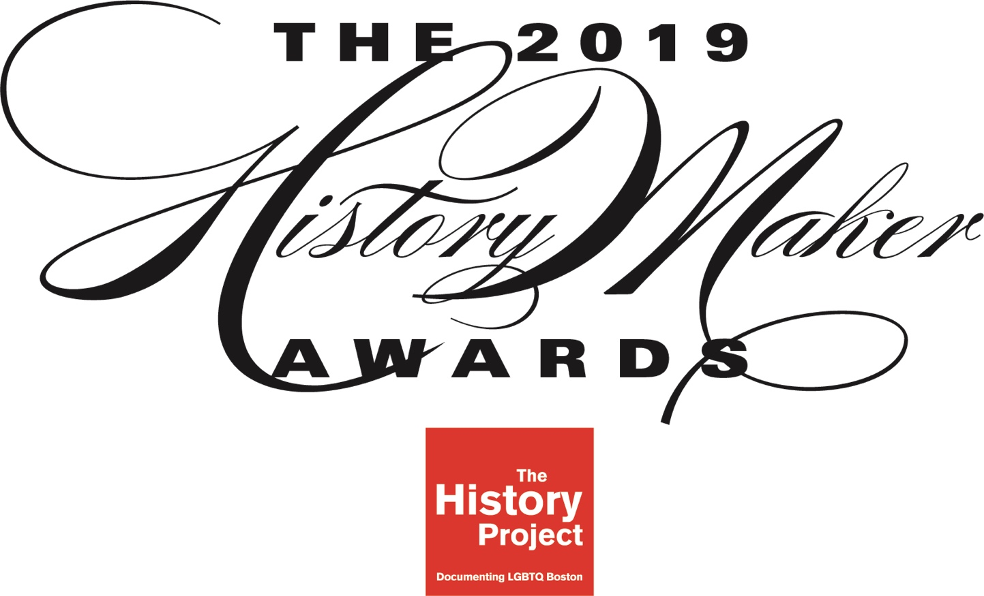

SPONSOR OPPORTUNITIES

The History Project
29 Stanhope Street
Boston, MA 02116

For more information, email Joan Ilacqua at info@historyproject.org

On October 3, 2019, The History Project invites you to celebrate Boston’s and Massachusetts’ lesbian, gay, bisexual, transgender and queer history, and to join us in honoring the community members who make history every day. At this ceremony and reception, we will present two awards to local history makers.

The HistoryMaker Award
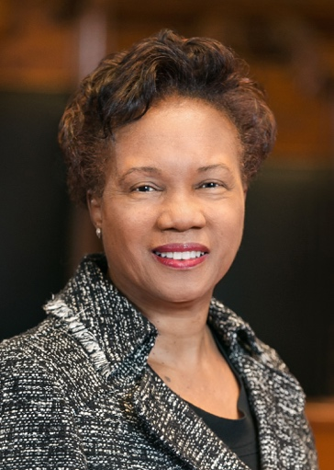
The History Project has presented the HistoryMaker Award since 2009 to an individual or organization whose lifetime achievements have had a significant and positive effect on Boston and Massachusetts’ LGBTQ communities. Past recipients of the award include Barney Frank; Mary L. Bonauto; Grace Sterling Stowell; Byron Rushing, Abe Rybeck, Susan Ryan-Vollmar, Larry Kessler, and Orlando Del Valle. The History Project is pleased to announce that Denise Simmons is the 2019 recipient of The HistoryMaker Award and will be honored at our reception on October 3.

The Lavender Rhino Award
The Lavender Rhino Award is presented annually to an emerging activist or organization in the Boston area. The History Project will announce the 2019 Lavender Rhino Award recipient in September 2019.

Event Location: St. Botolph Club, 199 Commonwealth Avenue, Boston, Mass.
The 2019 HistoryMaker Awards will take place at the elegant and historic St. Botolph Club in Boston’s Back Bay.

About The History Project
Established in 1980 by a group of historians, activists, and archivists, The History Project is the only organization focused exclusively on preserving the history of New England’s LGBTQ community and making that history accessible to researchers and the public.

The group maintains one of the largest independent LGBTQ archives in the nation – more than 1 million records, and which includes more than 150 collections from organizations, business, and individuals. Collections range from the records of early Gay Liberation organizations and photographs of pre-Stonewall Boston to objects such as T-shirts and buttons and materials documenting the marriage equality movement. These documents and artifacts are processed and made available to researchers by a dedicated group of volunteers from the community who donates hundreds of hours of their time annually.

THP’s many outreach activities include Out of the Archives, a series of talks focused on our archival collections; Out in Public, a series of lectures, discussions, and programs in venues in the Boston area, often in partnership with local organizations; Into the Streets, our walking tours program; and the HistoryMaker Awards.

The History Project is an all-volunteer organization that depends on the generosity of individuals and foundations for support.
EVENT SPONSORSHIP

Named in honor of Boston’s historic Gay and Lesbian Bars, our five sponsorship levels offer a variety of opportunities to let our community know you support The History Project and HistoryMaker awardees.

saints level  $5,000 | napoleons level  $2,500 | marquee level  $1,000
8 tickets to HistoryMaker Awards reception  Listing (including logo when appropriate) in press releases, on THP website, and on event webpages  Logo placement on print and electronic invitations  Recognition on printed program and multimedia presentation  Verbal recognition from stage  Three group invitations to private THP events of your choice:  - a walking tour (up to 20 guests);  - an archives processing party and talk (up to 10 guests); or  - a history presentation to your group (number of guests is negotiable, depending on space availability) | 6 tickets to HistoryMaker Awards reception  Listing (including logo when appropriate) in press releases, on THP website, and on event webpages  Logo placement on print and electronic invitations  Recognition on printed program and multimedia presentation  Verbal recognition from stage  Two group invitations to private THP events of your choice:  - a walking tour (up to 20 guests);  - an archives processing party and talk (up to 10 guests); or  - a history presentation to your group (number of guests is negotiable, depending on space availability) | 4 tickets to HistoryMaker Awards reception  Recognition on printed program and multimedia presentation  Verbal recognition from stage  One group invitation to a private THP event of your choice:  - a walking tour (up to 20 guests);  - an archives processing party and talk (up to 10 guests); or  - a history presentation to your group (number of guests is negotiable, depending on space availability) | sporters level  $500  2 tickets to HistoryMaker Awards reception  Recognition on printed program and on event webpages  _______  buddies level  $300  1 ticket to HistoryMaker Awards reception  Recognition on printed program and on event webpages

THE HISTORYMAKER AWARDS BY THE NUMBERS

Each year, over 125 people attend the HistoryMaker Awards, and thousands more interact with The History Project via our mailing list and social media, through in-person events, and through their research projects. Sponsorship offers a unique opportunity to reach an educated, involved, and discerning segment of Boston’s and Massachusetts’ LGBTQ community and their allies.

The History Project’s Subscriber Base
Physical Mailing List Subscribers | 1,662
Email Subscribers | 1,667
Twitter Followers | 1,160
Instagram Followers | 1,703
Facebook Subscribers | 3,054

Quick Facts about The History Project’s Reach
- Most History Project subscribers are concentrated in the Boston area, with many more spread across Massachusetts, and throughout major U.S. metropolitan areas.
- Number of estimated community members from the Boston area and beyond who attend events sponsored by The History Project annually: 2,000
- Number of average visits per month to our website, www.historyproject.org: 2,500

For more information about the impact and reach of The History Project contact Board Co-Chair Joan Ilacqua at info@historyproject.org.

SPONSOR RESPONSE FORM

- SAINTS LEVEL | $5,000 | - SPORTERS LEVEL | $500
- NAPOLEONS LEVEL | $2,500 | - BUDDIES LEVEL | $300
- MARQUEE LEVEL | $1,000

Check the level at which you’d like to join The History Project as a Supporter of our 2019 HistoryMaker Awards honoring Denise Simmons.

IF PAYING BY CREDIT CARD, PLEASE LIST BILLING ADDRESS FOR CARD. ALL FIELDS ARE REQUIRED.

NAME
______________________ __________________________________
COMPANY/ORGANIZATION
______________________ __________________________________
ADDRESS
______________________ __________________________________
CITY/STATE/ZIP
______________________ __________________________________
EMAIL/PHONE

METHOD OF PAYMENT
- CHECK ENCLOSED (Make check payable to “The History Project”)
- CREDIT CARD
- PayPal (https://tinyurl.com/hm-sponsors)
__________________________________________________
CREDIT CARD #
__________________________________________________
AMOUNT OF PAYMENT
__________________________________________________
CVV2/CID Code
__________________________________________________
EXPIRATION DATE

__________________________________________________
AUTHORIZED SIGNATURE
__________________________________________________
DATE OF SIGNING

RETURN FORM AND PAYMENT TO: THE HISTORY PROJECT | 29 STANHOPE STREET | BOSTON, MA 02116
OR VIA PAYPAL AT: www.paypal.me/historyproject

QUESTIONS? CONTACT BOARD CO-CHAIR JOAN ILACQUA AT INFO@HISTORYPROJECT.ORG.

The History Project is a 501(c)3 nonprofit organization. Contributions are tax-deductible as allowed by law.

